2023 TTV/SSV Primary Schools Cup Final
Dear Players, Parents and Teachers
Welcome to the State Finals of the TTV/SSV Primary School Cup, where students will be competing throughout the day for the State Championships. Play will take place in Stadium 5 at MSAC.
The competition has 2 categories – Grade 5 & 6 boys/mixed and Grade 5 & 6 girls. Each division will play a round robin of matches to determine their final placing, and then be reseeded into another round robin to determine a winner for each division.
Each match consists of five individual matches (four singles and one doubles) which are best of three games, i.e. a match is finished when a player or doubles pair has won two games. All individual matches will be played.
Players from one team should umpire the first two singles, then players from the other team should umpire the last two singles. Ask a player who is having a bye (or an adult) to umpire the doubles. Please start as quickly as possible so matches do not run over the scheduled time.
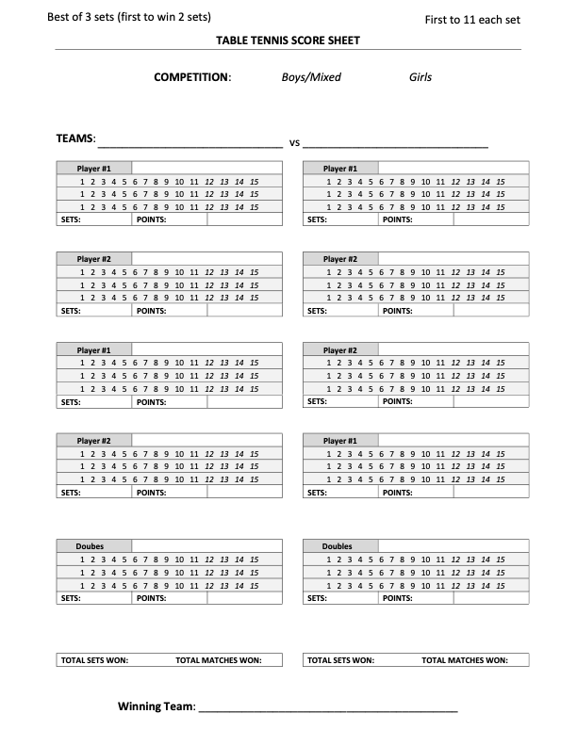
A scoresheet for a game will look like this. A set is won by being the first player to win 11 points, and be at least 2 points ahead of his or her opponent. If both players have won 10 points, then the first player to get a 2-point lead wins the set. A match is best out of 3 sets. A game is the best of 5 matches.

All players attending need to bring a bat with them as TTV (TABLE TENNIS VICTORIA) is unable to provide bats for all the students.
First Round Teams
Grade 5 & 6 Boys/Mixed – Group A
1 | Team 1- Mount View E | Player 1, Player 2
2 | Team 2- Holy Rosary A | Player 1, Player 2
3 | Team 3- Doncaster Gardens A | Player 1, Player 2
4 | Team 4- St Mary's Hamilton A | Player 1, Player 2

Grade 5 & 6 Boys/Mixed – Group B
1 | Team 5- Glendal A | Player 1, Player 2
2 | Team 6- Mount View A | Player 1, Player 2
3 | Team 7- Doncaster Gardens B | Player 1, Player 2
4 | Team 8- Holy Rosary B | Player 1, Player 2

Grade 5 & 6 Boys/Mixed – Group C
1 | Team 9- Glendal D | Player 1, Player 2
2 | Team 10- St Mary's Hamilton B | Player 1, Player 2
3 | Team 11- Holy Rosary F | Player 1, Player 2
4 | Team 12- Mount View B | Player 1, Player 2

Grade 5 & 6 Boys/Mixed – Group D
1 | Team 13- Mount View F | Player 1, Player 2
2 | Team 14- Holy Rosary C | Player 1, Player 2
3 | Team 15- Doncaster Gardens C | Player 1, Player 2
4 | Team 16- Glendal B | Player 1, Player 2

Grade 5 & 6 Boys – Group E
1 | Team 17- Glendal C | Player 1, Player 2
2 | Team 18- Mount view C | Player 1, Player 2
3 | Team 19- Doncaster Gardens D | Player 1, Player 2
4 | Team 20- Holy Rosary D | Player 1, Player 2

Grade 5 & 6 Boys/Mixed – Group F
1 | Team 21- Holy Rosary E | Player 1, Player 2
2 | Team 22- Holy Rosary G | Player 1, Player 2
3 | Team 23- Doncaster Gardens E | Player 1, Player 2
4 | Team 24- Mount View D | Player 1, Player 2

Grade 5 & 6 Girls – Group A
1 | Team 1- Holy Rosary A | Player 1, Player 2
2 | Team 2- Glendal A | Player 1, Player 2
3 | Team 3- Doncaster Gardens A | Player 1, Player 2
4 | Team 4- Doncaster Gardens D | Player 1, Player 2

Grade 5 & 6 Girls – Group B
1 | Team 5- Holy Rosary B | Player 1, Player 2
2 | Team 6- Mount View A | Player 1, Player 2
3 | Team 7- Doncaster Gardens E | Player 1, Player 2
4 | Team 8- Holy Rosary F | Player 1, Player 2

Grade 5 & 6 Girls – Group C
1 | Team 9- Doncaster Gardens B | Player 1, Player 2
2 | Team 10- Holy Rosary C | Player 1, Player 2
3 | Team 11- Glendal B | Player 1, Player 2
4 | Team 12- Mount View B | Player 1, Player 2

Grade 5 & 6 Girls – Group D
1 | Team 13- Holy Rosary D | Player 1, Player 2
2 | Team 14- Mount View D | Player 1, Player 2
3 | Team 15- Doncaster Gardens C | Player 1, Player 2
4 | Team 16- Glendal D | Player 1, Player 2

Grade 5 & 6 Girls – Group E
1 | Team 17- Glendal C | Player 1, Player 2
2 | Team 18- Mount view C | Player 1, Player 2
3 | Team 19- Mount Martha A | Player 1, Player 2
4 | Team 20- Holy Rosary E | Player 1, Player 2

First Round Draws
Format: 24 Teams of Grade 5/6 Boys/Mixed and Girls split into 6 pools of 4.
This table can be read as: BA1V4 = Boys/Mixed Group A Team 1 vs Team 4.
T1= Table 1. T2= Table 2.
Boys/Mixed
 | T1 | T2 | T3 | T4 | T5 | T6 | T7 | T8 | T9 | T10 | T11 | T12
10am | BA1V4 | BA2V3 | BB1V4 | BB2V3 | BC1V4 | BC2V3 | BD1V4 | BD2V3 | BE1V4 | BE2V3 | BF1V4 | BF2V3
10:45am | BA1V3 | BA2V4 | BB1V3 | BB2V4 | BC1V3 | BC2V4 | BD1V3 | BD2V4 | BE1V3 | BE2V4 | BF1V3 | BF2V4
11:30pm | BA1V2 | BA3V4 | BB1V2 | BB3V4 | BC1V2 | BC3V4 | BD1V2 | BD3V4 | BE1V2 | BE3V4 | BF1V2 | BF3V4
Short break for lunch & to schedule the next round

Girls
 | T13 | T14 | T15 | T16 | T17 | T18 | T19 | T20 | T21 | T22
10am | GA1V4 | GA2V3 | GB1V4 | GB2V3 | GC1V4 | GC2V3 | GD1V4 | GD2V3 | GE1V4 | GE2V3
10:45am | GA1V3 | GA2V4 | GB1V3 | GB2V4 | GC1V3 | GC2V4 | GD1V3 | GD2V4 | GE1V3 | GE2V4
11:30am | GA1V2 | GA3V4 | GB1V2 | GB3V4 | GC1V2 | GC3V4 | GD1V2 | GD3V4 | GE1V2 | GE3V4
Short break for lunch & to schedule the next round

Boys/Mixed First Round Results
Boys/Mixed Group A Results
Team | Rd1 | Rd2 | Rd3 | Wins | Place
Team 1
Team 2
Team 3
Team 4

Boys/Mixed Group B Results
Team | Rd1 | Rd2 | Rd3 | Wins | Place
Team 5
Team 6
Team 7
Team 8

Boys/Mixed Group C Results
Team | Rd1 | Rd2 | Rd3 | Wins | Place
Team 9
Team 10
Team 11
Team 12

Boys/Mixed Group D Results
Team | Rd1 | Rd2 | Rd3 | Wins | Place
Team 13
Team 14
Team 15
Team 16
Boys/Mixed Group E Results
Team | Rd1 | Rd2 | Rd3 | Wins | Place
Team 17
Team 18
Team 19
Team 20

Boys/Mixed Group F Results
Team | Rd1 | Rd2 | Rd3 | Wins | Place
Team 21
Team 22
Team 23
Team 24

Girls First Round Results
Girls Group A Results
Team | Rd1 | Rd2 | Rd3 | Wins | Place
Team 1
Team 2
Team 3
Team 4

Girls Group B Results
Team | Rd1 | Rd2 | Rd3 | Wins | Place
Team 5
Team 6
Team 7
Team 8

Girls Group C Results
Team | Rd1 | Rd2 | Rd3 | Wins | Place
Team 9
Team 10
Team 11
Team 12

Girls Group D Results
Team | Rd1 | Rd2 | Rd3 | Wins | Place
Team 13
Team 14
Team 15
Team 16
Girls Group E Results
Team | Rd1 | Rd2 | Rd3 | Wins | Place
Team 17
Team 18
Team 19
Team 20

The teams will be reseeded for the second round based on wins and points. The higher the wins and points scored, the higher the division the team will be seeded in for the next round.

Second Round Teams
Grade 5 & 6 Boys/Mixed – Division 1
1 |  | Player 1, Player 2
2 |  | Player 1, Player 2
3 |  | Player 1, Player 2
4 |  | Player 1, Player 2

Grade 5 & 6 Boys/Mixed – Division 2
1 |  | Player 1, Player 2
2 |  | Player 1, Player 2
3 |  | Player 1, Player 2
4 |  | Player 1, Player 2

Grade 5 & 6 Boys/Mixed – Division 3
1 |  | Player 1, Player 2
2 |  | Player 1, Player 2
3 |  | Player 1, Player 2
4 |  | Player 1, Player 2

Grade 5 & 6 Boys/Mixed – Division 4
1 |  | Player 1, Player 2
2 |  | Player 1, Player 2
3 |  | Player 1, Player 2
4 |  | Player 1, Player 2

Grade 5 & 6 Boys – Division 5
1 |  | Player 1, Player 2
2 |  | Player 1, Player 2
3 |  | Player 1, Player 2
4 |  | Player 1, Player 2

Grade 5 & 6 Boys/Mixed – Division 6
1 |  | Player 1, Player 2
2 |  | Player 1, Player 2
3 |  | Player 1, Player 2
4 |  | Player 1, Player 2

Grade 5 & 6 Girls – Division 1
1 |  | Player 1, Player 2
2 |  | Player 1, Player 2
3 |  | Player 1, Player 2
4 |  | Player 1, Player 2

Grade 5 & 6 Girls – Division 2
1 |  | Player 1, Player 2
2 |  | Player 1, Player 2
3 |  | Player 1, Player 2
4 |  | Player 1, Player 2

Grade 5 & 6 Girls – Division 3
1 |  | Player 1, Player 2
2 |  | Player 1, Player 2
3 |  | Player 1, Player 2
4 |  | Player 1, Player 2

Grade 5 & 6 Girls – Division 4
1 |  | Player 1, Player 2
2 |  | Player 1, Player 2
3 |  | Player 1, Player 2
4 |  | Player 1, Player 2

Grade 5 & 6 Girls – Division 5
1 |  | Player 1, Player 2
2 |  | Player 1, Player 2
3 |  | Player 1, Player 2
4 |  | Player 1, Player 2

Second round draw:
Boys/Mixed
 | T1 | T2 | T3 | T4 | T5 | T6 | T7 | T8 | T9 | T10 | T11 | T12
12:30 pm | B1 1V4 | B1 2V3 | B2 1V4 | B2 2V3 | B3 1V4 | B3 2V3 | B4 1V4 | B4 2V3 | B5 1V4 | B5 2V3 | B6 1V4 | B6 2V3
1:15 pm | B1 1V3 | B1 2V4 | B2 1V3 | B2 2V4 | B3 1V3 | B3 2V4 | B4 1V3 | B4 2V4 | B5 1V3 | B5 2V4 | B6 1V3 | B6 2V4
2:00 pm | B1 1V2 | B1 3V4 | B2 1V2 | B2 3V4 | B3 1V2 | B3 3V4 | B4 1V2 | B4 3V4 | B5 1V2 | B5 3V4 | B6 1V2 | B6 3V4
2:45 pm | Presentation

Girls
 | T13 | T14 | T15 | T16 | T17 | T18 | T19 | T20 | T21 | T22
12:30pm | G1 1V4 | G1 2V3 | G2 1V4 | G2 2V3 | G3 1V4 | G3 2V3 | G4 1V4 | G4 2V3 | G5 1V4 | G5 2V3
1:15 pm | G1 1V3 | G1 2V4 | G2 1V3 | G2 2V4 | G3 1V3 | G3 2V4 | G4 1V3 | G4 2V4 | G5 1V3 | G5 2V4
2:00 pm | G1 1V2 | G1 3V4 | G2 1V2 | G2 3V4 | G3 1V2 | G3 3V4 | G4 1V2 | G4 3V4 | G5 1V2 | G5 3V4
2:45 pm | Presentation

Boys/Mixed Second Round Results
Boys/Mixed Division 1 Results
Team | Rd1 | Rd2 | Rd3 | Wins | Place
Team
Team
Team
Team

Boys/Mixed Division 2 Results
Team | Rd1 | Rd2 | Rd3 | Wins | Place
Team
Team
Team
Team

Boys/Mixed Division 3 Results
Team | Rd1 | Rd2 | Rd3 | Wins | Place
Team
Team
Team
Team

Boys/Mixed Division 4 Results
Team | Rd1 | Rd2 | Rd3 | Wins | Place
Team
Team
Team
Team
Boys/Mixed Division 5 Results
Team | Rd1 | Rd2 | Rd3 | Wins | Place
Team
Team
Team
Team

Boys/Mixed Division 6 Results
Team | Rd1 | Rd2 | Rd3 | Wins | Place
Team
Team
Team
Team

Girls Second Round Results
Girls Division 1 Results
Team | Rd1 | Rd2 | Rd3 | Wins | Place
Team
Team
Team
Team

Girls Division 2 Results
Team | Rd1 | Rd2 | Rd3 | Wins | Place
Team
Team
Team
Team

Girls Division 3 Results
Team | Rd1 | Rd2 | Rd3 | Wins | Place
Team
Team
Team
Team

Girls Division 4 Results
Team | Rd1 | Rd2 | Rd3 | Wins | Place
Team
Team
Team
Team
Girls Division 5 Results
Team | Rd1 | Rd2 | Rd3 | Wins | Place
Team
Team
Team
Team

